**FAMU/FSU College of Engineering**

**Department of Mechanical Engineering**

**Midterm 1 Report**

**Team 23/15: Hybrid Thermal/Electrical Energy Storage System for OGZEB**

**Names:**

**Tristian Jones- ME**

**Nicholas Kraft- ME**

**Artur Souza- ME**

**Lucas Santos- ME**

**Corey Allen- EE**

**Anthony Cappetto- EE**

**Kristian Hogue- EE**

**Date: October 25th, 2013**



**Table of Contents**

1. Abstract/ Executive Summary1
2. Project Overview1
3. Sponsor Requirement1
4. Scope2
5. Goal2
6. Objectives2
7. Design & Analysis3
8. Proposed Energy Flow Functional Analysis3
9. Thermal System Design Concepts & Evaluation5
10. Electrical Design Concepts & Evaluation9
11. Programming Needs & Control11
12. Procurement11
13. Conclusions12
14. Future Work13
15. Gantt Chart & Scheduling13
16. References16
17. **Abstract/ Executive Summary**

The OGZEB (Off Grid Zero Emissions Building) is located on the Florida State University campus and is sponsored by FSU’s Environmental and Sustainability Center. It is a 1064 square foot platinum LEED NC certified building. The building is split into an 800 square foot graduate style flat and 264 feet of offices. The building is also an actively used laboratory that is operating 24 hours a day. All the energy in the building is either converted from geothermal, solar thermal or photovoltaic panels. Together, all of these energy sources give power to the OGZEB.

Most of the energy used by the OGZEB is provided by solar energy. In Florida, solar energy is widely available which makes it one of the most ideal solutions for powering the OGZEB. A 6.9 kW solar array converts the sun’s rays into electrical energy. However, the OGZEB will not need this much energy on an average day. The extra electricity is currently used to charge a series of batteries, to be used during nocturnal hours when the solar cells are not producing enough energy to meet the house’s needs. In the event of total battery drainage, the house is powered by a hydrogen fuel cell using pre-purchased hydrogen. Current battery storage system is out of date and cannot store enough energy to power the house through the night.

The purpose of this senior design project is to engineer an energy storage system that can harness the excess energy derived from the OGZEB’s solar panels. In order for this system to meet the goals and maintain the LEED (Leadership in Energy & Environmental Design) platinum certification, our team must upgrade the buildings battery network and develop a thermal energy storage system to work alongside the batteries.

Thus, students of electrical engineering will be in charge of improving the battery system from collecting data of energy consumption of the house and the power provided by solar panels, in addition, select which battery will be used for the project. For students of mechanical engineering it will be necessary to choose a concept for thermal energy storage system that can be used in the house, taking into consideration factors such as cost, size, safety, feasibility and efficiency.

1. **Project Overview**
   1. **Sponsor requirement**

In order to design and build the most appropriate energy storage system for the OGZEB, it is necessary to meet some requirements. One of them is that the system has to be optimized, providing a reduced power loss, increasing the overall efficiency and making a better use of the energy available from the environment. The system must also have zero net emissions and also combine thermal and electrochemical portions. Besides those requirements, economical aspects should also be considered, so that, a minimum upkeep is expected, as well as the budget should not be changed.

* 1. **Scope**

The purpose of this senior design project is to engineer an energy storage system that can harness the excess energy derived from the OGZEB’s solar panels. In addition to storing this energy, the improved design will also possess the capability to redirect this energy back to the power grid. With this capability, the home owner will be able to fully power their house during times of lower energy production and sell the excess energy back to the power company. In order for this system to meet the goals stated (see Objectives) and maintain the LEED (Leadership in Energy & Environmental Design) platinum certification, our team must upgrade the buildings battery network and develop a thermal energy storage system to work alongside the batteries.

* 1. **Goal**

With the conclusion of this project, we expect to have designed and built a hybrid thermal/electrochemical system that can store the excess energy generated by the photovoltaic panels in the OGZEB and have the system fully implemented by the end of the second semester. The project should meet all or most of the major goals listed in the objectives section. Furthermore the system should satisfy the desires of the customer in all aspects.

* 1. **Objectives**

The main objective for the OGZEB is to develop an energy management system that is more reliable and efficient than the current system in place. The SR-230 solar panels are producing an excess amount of energy (~6.9 kW) and the load is only using about 17% of that energy. Since the solar panels are not producing a constant source of energy, creating an energy storage system is the most important objective of the OGZEB project.

Although the energy storage aspect of the project takes high priority, there are other goals that cannot be neglected and some others that will make the process easier. These objectives are as follows:

1. Design a combined thermal and electrochemical system.

* Battery system redesigned
* Excess energy storage
* Battery thermal management

1. Minimal power loss.

* Standalone system efficiency vs grid connected system

1. Stay within budget.
2. Maintain a Platinum LEED certification.
3. Create a system that can be easily tested and maintained for future research.
4. Design concept for possible connection to the energy grid.

* Analysis and cost components
* Possible profit from selling unused energy to the grid

1. Design a system simple enough to be mass-marketable or at least reasonably reproducible

1. **Design and Analysis**
   1. **New Proposed Energy Flow Functional Analysis**

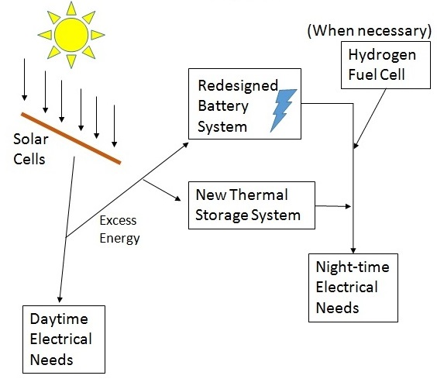

Figure 1. Functional Analysis of Proposed Energy Flow

The energy flow within the OGZEB house is shown in the Functional Analysis diagram above (Figure 1). Each individual component described below has its own importance and serves a purpose.

*1. Photovoltaic Solar Cells & Daytime Needs*

The solar cells collect the electromagnetic radiation emitted by the sun and convert the energy into electricity via the photovoltaic effect. The photovoltaic effect occurs when the individual photons of light collected by the solar cells create electron-hole pairs and stimulate a current (electron flow) across the p-n junction of the silicon material. All of the electrical needs during the daytime can be supplied by the thirty PV panels on the roof of the house.

*2. Redesigned Battery Array, Thermal Storage, & Nighttime Needs*

Since the solar cells produce more than the required electrical needs of the house during the day there is a battery system in place currently that collect and store the excess energy being produced by the solar panels. This excess energy storage is used to power the house at night. The current battery system is out of date and incapable of storing enough energy to meet the nighttime needs of the house so a battery redesign and procurement will need to take place. In junction with the battery system more power will be saved by implementing Ice Generation (Cold Storage) within the Air Conditioning system to relieve the chiller at night and save power. The Cold Storage will be described in greater detail within the Thermal Design Concepts section.

*3. Hydrogen Fuel Cell*

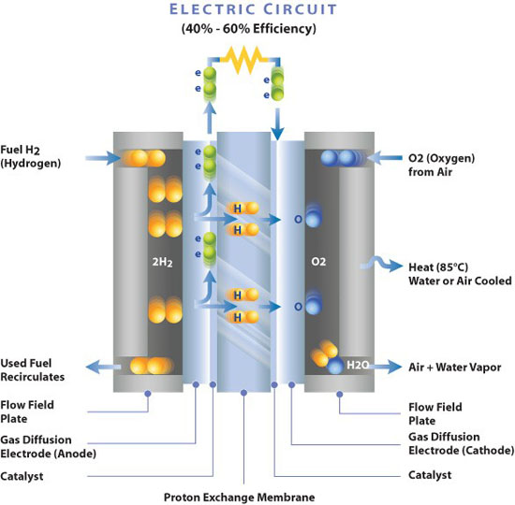 If both energy storage systems fail to supply enough energy at night, a Hydrogen Fuel Cell is in place to supply the needed energy. A hydrogen fuel cell works through a chemical process similar to a battery. Within the fuel cell lies an anode (-), electrolyte membrane, and a cathode (+). The anode takes the electrons from the two H2 (hydrogen) and allows the electrons to flow across the external circuit to the anode. The anode containing the electrons recombine with a supply of O2 (Oxygen) atoms and the hydrogen ions that have traveled across the electrolyte to the anode side. A diagram showing this process is shown in Figure 2.

Figure 2. Hydrogen Fuel Cell Operation Diagram [1]

* 1. **Thermal System Design Concepts & Evaluation**

Originally, there were five different forms of thermal/mechanical energy storage the design team was considering. These concepts are Compressed Air Energy Storage (CAES), Molten Salt Energy Storage, Cold Storage, Flywheel Storage, and Hydroelectric Storage. Each of thfese different concepts have their own advantages and their disadvantages which are described below along with a brief description of how they work. To help with the selection process the decision matrix shown in Figure 3 was also created. Although Flywheel Storage came in at a close second to Ice Generation, both Flywheel and Hydroelectric Storage were eliminated due to the project description limiting the selection to Thermal/Thermoelectric Storage. Therefore the selection was mostly between CAES, Molten Salt, and Ice Storage.

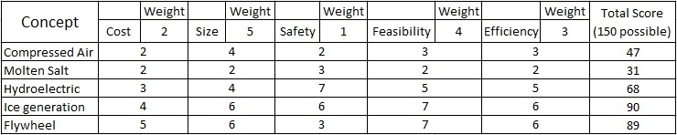

Figure 3. Thermal Storage System Decision Matrix

*1. Compressed Air Energy Storage*

Compressed Air Energy Storage is a concept used mostly for larger scale power plants. In CAES, an air compressor would run during the daytime when the solar panels can produce power. The compressed air would then be stored in an above ground compressed air storage tank/tanks. These tanks would have to be heavily insulated to prevent as much heat loss as possible. At night, the air would be allowed out of the storage tank and flow through a recouperator (heat recovery) and then through turbine which would be in combination with a generator for the mechanical to electrical energy conversion. A diagram of a typical CAES system is displayed in Figure 4.

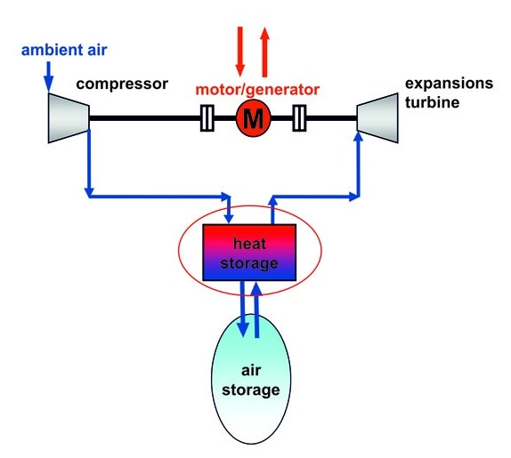

Figure 4. Typical model of CAES. [2]

Some advantages of CAES are its ease of understanding and the fact that it COULD be size efficient. The concept itself is basically taking a simple Brayton Cycle and inserting an air storage reservoir in between the compression and expansion. The system could also be size efficient relative to other concepts because air storage tanks don’t have to take up too much space. This leads to a disadvantage as well because with an above ground air storage tank comes a much more limited amount of air storage which leads to less power output and a smaller efficiency. Most CAES power plants use large underground caverns to store the compressed air which allows for a very large supply when needed. The OGZEB house is on a much smaller scale in terms of energy storage and there is not enough space for that large of a capacity for storage. Another disadvantage in our case is the multiple energy conversions could lead to lower efficiencies, especially with the smaller scale components. Perhaps the largest disadvantage to CAES is the emissions coming from the combustion process. This would interfere with the zero emission requirement of the building.

*2. Molten Salt Energy Storage*

A second concept that was considered was Molten Salt Energy Storage. In this concept, a molten salt heat transfer fluid is either stored in a tower where multiple heliostats reflect rays and heat up the salt to very high temperatures (usually above 1000˚F). Another option would be to run the salt through a series of parabolic solar troughs where the rays are reflected onto the tube (located at the focal point) containing the salt. The salt after heated up would travel to a thermal storage tank where it is allowed to flow through a heat exchanger that takes the place of a boiler in a Rankine Cycle. The heat exchanger would create steam which would run through a steam turbine/generator producing power. The excess power from the PV panels could be used to power the electrical powered components involved such as the pumps in both the salt cycle and steam-power cycle. A diagram illustrating Molten Salt Energy Storage is shown below in Figure 5.

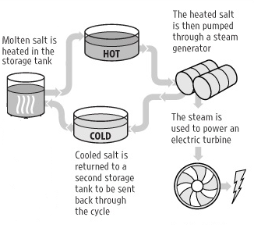

Figure 5. Molten Salt Thermal Storage Diagram

Some advantages of Molten Salt energy storage are its simplicity in terms of understanding and its low emission capability. Because it takes the place of a boiler, no combustion needs to take place which eliminates emissions and keeps the process green. Some disadvantages are the substantial amount of space the system would take up, the expensiveness of the materials, and like CAES there are multiple energy conversions in the steam powered cycle attached to the molten salt system.

*3. Ice Storage*

A third concept we considered highly was Ice Thermal Storage. In Ice Storage, ice is generated by flowing below freezing temperature ethylene glycol (antifreeze) through a series of tubes in a thermal storage tank containing water. The ethylene glycol is chilled to below freezing temperature using a standard chiller. More specifically the ethylene glycol runs through the evaporator heat exchanger within the chiller where it loses energy to the refrigerant. A diagram showing a standard chiller refrigeration cycle is displayed in Figure 6a and the ice storage concept combined with the chiller is shown in Figure 6b.

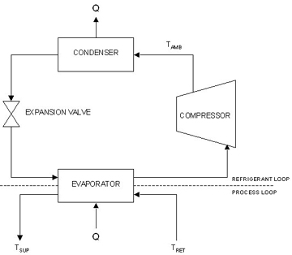

Figure 6a. Standard Chiller Refrigeration Cycle [3]

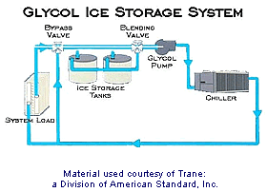

Figure 6b. Ice Storage Concept Combined with Chiller [4]

Glycol ice storage systems present the system designer with numerous benefits. First is the ability to use a standard packaged chiller. They offer an opportunity to reduce pump horsepower, and they require few accessories. The choice of either modular storage tanks or encapsulated ice systems not only offer application flexibility, but costs and reliable performance as well. Simple control schemes can be used, and like all ice storage systems - volume and space requirements per ton-hour of storage are considerably lower than those for chilled water storage [4]. Some disadvantages come with having to design a heat transfer system for glycol rather than water. Space is also limited within the OGZEB house property to place the storage tanks.

* 1. **Electrical Design Concepts & Evaluation**

The design concept for batteries is very straight forwarded. Our concept is to improve upon the previous battery banks. To improve the system is somewhat of a broad term when it comes to batteries. If the battery size is decreased then we lose overall power that can be used for the house. Another option is to keep the batteries the same but change the type of batteries that are being use. However, this will lead to an overall rise in cost for the new system. These factors have allowed use to narrow down our design concept to 3 options.

*1. Decrease the size of the current battery*

Decrease the size of the current battery bank so maximum use of the batteries are possible. The current size of the battery bank is oversized. This can be seen the State Of Charge of the batteries during nighttime usages. There are many times when batteries have plenty of charge remaining before the next charging cycles occurs. By not using the maximum amount of energy in the batteries, the OGZEB is wasting energy and money.

To choose the size of the battery pack for this design, a MATLAB simulation will be used. This MATLAB code was provided to use by Mr. Mike Greenleaf. Mr. Greenleaf is a Ph.D. student at The Florida State University and specializes in battery modeling and simulation. By using this MATLAB simulation we can predict the load of the house and how the batteries will react to different conditions. The results of this program provided use will valuable information and graphed data that can be used for proper sizing strategies.

The advantage of decreasing the battery size is largely the cost factor. Batteries that can provide enough power to properly operate a house can be very expensive. Keeping the cost of this project to a minimum is a must, which is why resizing the batteries is one of the first design concepts.

The disadvantage of reducing the battery size is that the battery could possibly be reduced to a size too small to support the house at maximum operation. This will result in the complete energy usage of the batteries before they have a chance to recharge the following day. This will present two majors problems. The first problem is that the house will effectively run out of power to operate correctly. The second problem is that the batteries could be damaged if the state of charge is reduced to a critical point.

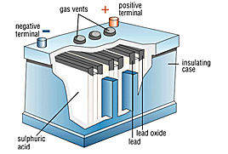

Figure 7. Lead Acid Battery

*2. Change in battery type is the second design concept.*

The current lead acid batteries associated with the house are on the low end of battery cost and performance. Using MATLAB simulation we can determine if this is a viable option. After this simulation is complete, a cost analysis will have to be performed to see if it is cheaper to buy a better quality battery.

The advantage of changing to a higher quality battery would result in a longer battery life and performance. A possible option would be to replace the lead acid batteries with LiFePO4. The size of LiFePO4 is also smaller than that of the lead acid type.

The disadvantage of changing to a higher quality battery is the cost factor. Sadly, the prices of LiFePO4 batteries are easily twice the price of lead acid batteries. This is the only disadvantage of changing to this battery

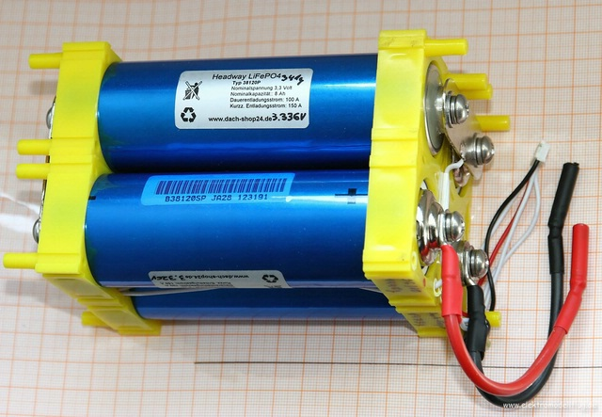

Figure 8. LiFePO4 Batteries

*3. Reduce Battery size and Battery Type*

The third design concept is a combination of design concept one and two. This would be to reduce the size of the battery pack while changing the type of battery. This would allow use to reduce the cost of the LiFePO4 because number of batteries needed would be less. The advantage of this design concept is the overall efficiency and size of the battery bank. The disadvantage is that the team needs to limit any possible error in there design. Not only will the team have to do an in-depth analysis to ensure the house can still operate at full capacity with a smaller battery design but the team will also have to be careful to make sure that money is not wasted from buying too many expensive batteries. Design concepts for project goals two, three, and four have not yet been discussed because the team has not finished the most important goal, which is the battery system redesign.

1. **Programming Needs and Control**

Currently here are no programming needs that must be addressed. There is a possibility if the house is connected to the grid that some extra programming will be needed. But at the current time the team cannot confirm if/how much will be needed when that step arrives.

The control aspects of this project range from a wide range of things. There is already a basic energy management for the current battery system. This however might have to be modified if the team makes major changes to the battery system. This has yet to be defined.

1. **Procurement**

For the Mechanical side of the project, the procurement phase of this project will begin after a final design is constructed. All efforts will be made to use recycled or used materials to follow the vision of the OGZEB as well as to reduce costs. When necessary new parts will be ordered or built. We currently have access to a water fountain which may be used to create a refrigeration cycle. The OGZEB’s current features can also be utilized.

For the Electrical side of the project, after the necessary parameters were taken into account, the team believes Lead Acid Batteries would be the most efficient for the OGZEB building. Parameters such as cost and safety were upheld to a high degree to ensure that the building would function properly without producing any harmful situations. Among the three options presented, Lead Acid batteries also have the highest safety rating and feasibility. The feasibility section takes into account the ease of access to additional batteries for replacement. The batteries must be readably available for home residents to replace in the future if any malfunctions occur. In addition, important comparisons included the batteries durability versus time. Lithium Ion batteries possess a longer battery life, but the difference in cost between Lead Acid and Lithium Ion batteries makes the latter choice futile. Lead Acid batteries will operate and store the appropriate amount of energy while ensuring that our budget will possess excess funds to be used for other components to the battery system. Funds provided by our administration will be utilized to purchase brand new lead acid batteries. The battery grouping, individual voltage size, and brand will be determined later on when more data is acquired. A decision matrix to help with the battery selection is displayed in Figure 9.

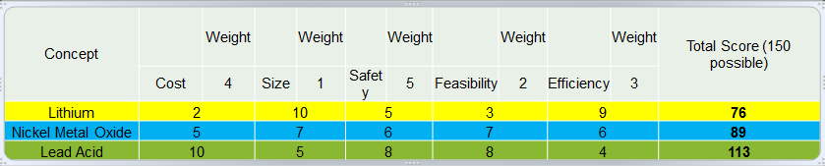

Figure . Decision Matrix for Battery Selection

1. **Conclusions**

Our group has decided that an ice production system is the best choice for this project. It is both feasible and has the necessary energy storage capability to get the house through the night. Now that a system has been selected, the design process can begin. This is a pivotal aspect of the project and will require heavy analysis in various fields of engineering to create a viable system. Responsibility for this design will reside chiefly on the group’s mechanical engineering students, with assistance from the electrical engineering students when needed. The EE students will be working to redesign the battery array for the house. A main portion of that is to model, quantify and justify different types of batteries in order to select the best option.

1. **Future Work**

For the Mechanical side of the project, the next step in the process is to create a detailed design for the proposed system. This will include the sizing of parts as well as the plan for integrating the system into the house. Extensive analysis will be necessary to size the system to optimize efficiency. Once we are confident in our design, supported through modeling, we will begin the procurement process. This work will occur concurrently with the work needed to complete the necessary deliverables.

For the Electrical, as we shift our perspective forward on the project, further battery testing and analyzing will be conducted. Lead acid and LiFePO4 battery systems will be simulated with the load of the house. In addition to the house load, the battery systems will be compared in terms of price, overall life expectancy, state of charge, and health. Gathering this data will lead us to constructing an optimal battery system that will sufficiently power the house without drastically depleting our funds. There will be a heavy focus on simulations regarding lead acid battery systems on the house since lead acid is decided to be the optimal choice. Once the simulations and data are accumulated, developing a battery thermal management system will be next on the agenda. The primary function of this system is to monitor the temperature of the battery banks and adjust the temperature of the air appropriately to ensure that the batteries will operate at maximum efficiency. The final objective for the team will be to engineer a method of hooking the house to the power grid. Research will be focused on what components are necessary for this to be achieved while maintaining safety regulations, ideal energy efficiency, and still being certified platinum LEED status. Once these specifications have been reached the ultimate goal will be to harness the additional energy coming from the solar panels and rerouting it to the power grid. This will increase the productivity of the overall system and produce some income for the residents of the house.

1. **Gantt Chart/ Scheduling**

The Gantt chart below shows the proposed work flow for the project for the Fall semester. The work breakdown structure is indicated by the colors of each header. The red headers show deliverables and the black sub-headers indicate the processes necessary to complete the deliverable above. Completion of each deliverable is dependent on the fulfillment of each sub-task. Tasks critical to the project are shown by an asterisk (*). Stars specify tasks that will take little time to complete. Certain assignments for the EE senior design project class that are not related to the project (such as homework assignments listed on the Master Deliverable Sheet) have been omitted. The task breakdown sheet below the Gantt chart shows specific milestones necessary to complete the project.

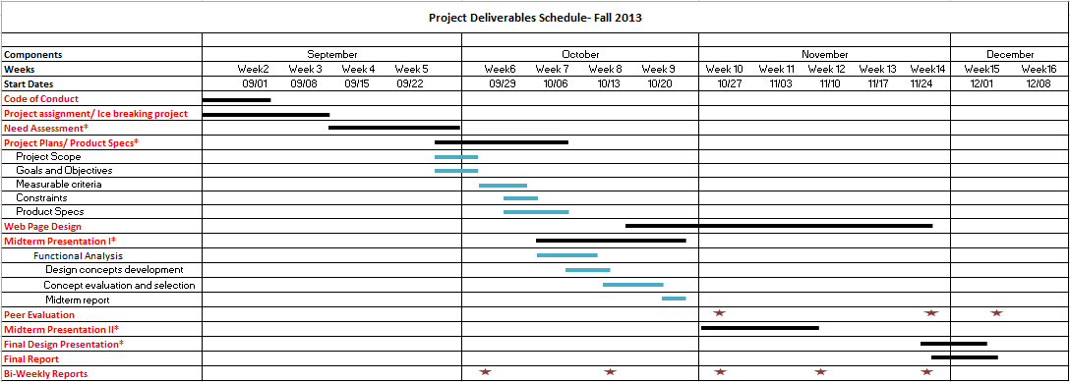

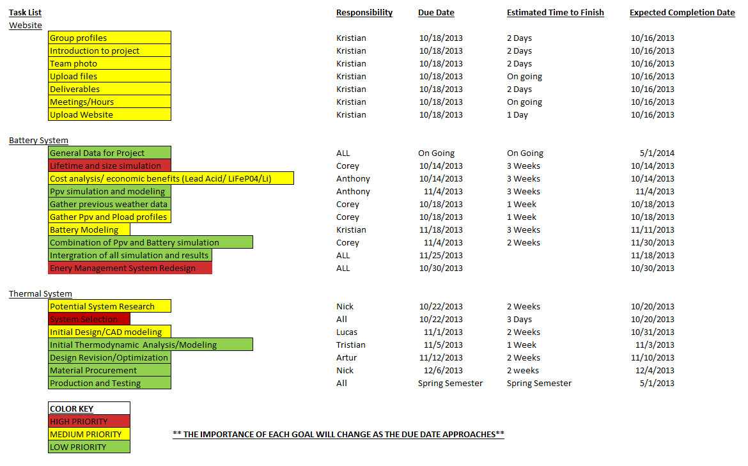

1. **References**

1. "Fuel Cells 2000." *- Fuel Cells And Hydrogen*. N.p., n.d. Web. 25 Oct. 2013. <http://www.fuelcells.org/base.cgim?template=fuel_cells_and_hydrogen>.

2. "KBB Underground Technologies." *» Research & Development*. N.p., n.d. Web. 25 Oct. 2013. <http://www.kbbnet.de/en/teaserwidgets/research-development/>.

3. "Factors Impacting Cooling Capacity of Recirculating Chillers." *Recirculating Chiller Cooling Capacity*. N.p., n.d. Web. 25 Oct. 2013. <http://www.lytron.com/Tools-and-Technical-Reference/Application-Notes/Factors-Impacting-Cooling-Capacity-of-Recirculating-Chillers>.

4. "Thermal Storage - Glycol Systems." *Thermal Storage - Glycol Systems*. N.p., n.d. Web. 25 Oct. 2013. <http://cipco.apogee.net/ces/library/xctg.asp>.